Installing tailwind css with vite using react :   
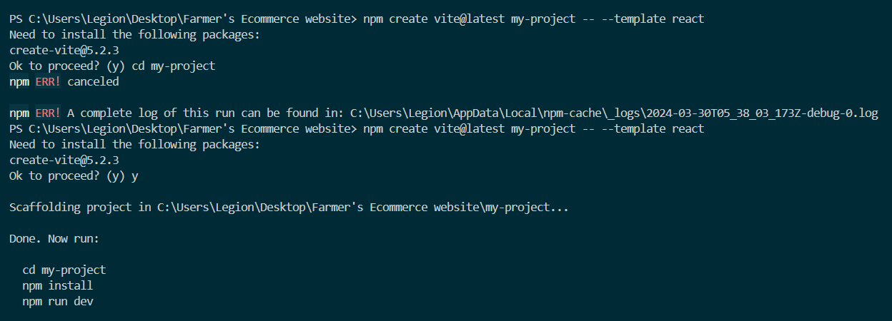

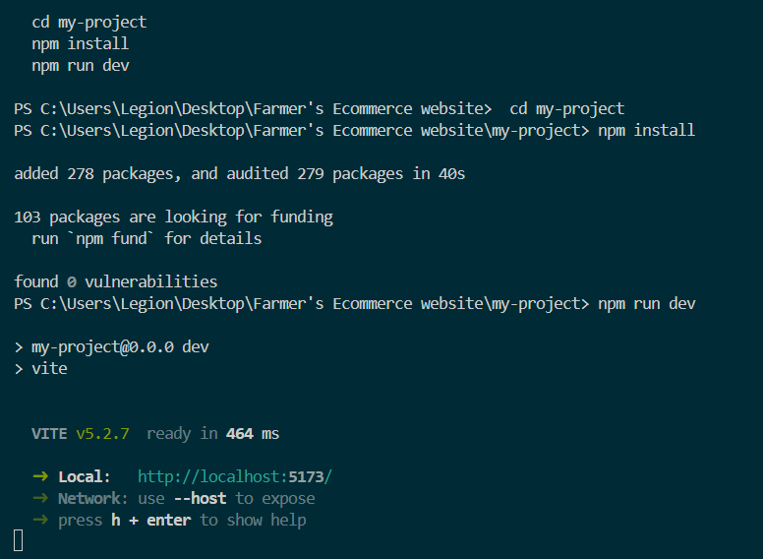

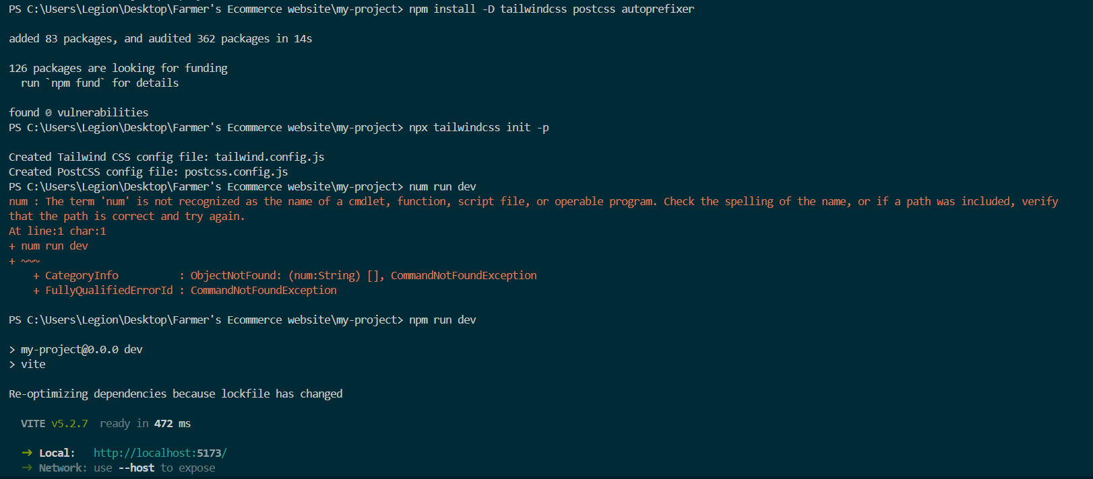

You can follow my step to install vite with tailwindcss.   
also follow the link below :

https://tailwindcss.com/docs/guides/vite